Mephibosheth Farms Angelic Riders Inc.
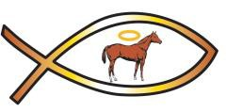
A therapeutic riding center utilizing foundation bred Quarter Horses.

DATE DONOR AMOUNT DONOR EMAIL CHECK#/CASH

Street Address: | (704 ) 233-9277 | Mailing Address:
820 Forest Hills School Rd N | Angelicriders.org | P.O. Box 285
Marshville, NC 28103 |  | Marshville, NC 2810

